**23CSE111**

**OBJECT ORIENTED PROGRAMMING**

**LAB REPORT**



**Department of Computer Science Engineering**

**Amrita School of Computing**

**Amrita Vishwa Vidyapeetham, Amaravati Campus**

**Name: L.Sri Karthikeya**

**Verified By Roll No: 24149**

|  |  |  |  |  |
| --- | --- | --- | --- | --- |
| **S.No.** | **Experiment Name** | **Page No.** | **Remarks** | **Signature** |
|  | **WEEK-1** |  |  |  |
| 1 | Installation Process of JDK | 3 |  |  |
| 2 | Simple Java Program for printing basic details of student | 5 |  |  |
|  | **WEEK-2** |  |  |  |
| 1 | Write a Java Program to find the factorial of a number | 7 |  |  |
| 2 | Write a Java Program to find the Fibonacci Series of given length | 9 |  |  |
| 3 | Write a Java Program to find the temperature from Celsius to Fahrenheit | 11 |  |  |
| 4 | Write a Java Program to find the Simple Interest | 12 |  |  |
| 5 | Write a Java Program to find the area of triangle using heron’s formula | 13 |  |  |
| 6 | Write a Java Program to find the area of rectangle | 15 |  |  |
|  | WEEK-3 |  |  |  |
| 1 | Write a java program with the following instructions:  a. Create class with name car.  b. Create 4 attributes named car color, car brand, fuel type, mileage.  c. Create 3 methods named start(), stop(), service().  d. Create 3 objects C1, C2, C3.  e. Create a constructor with parameters with car color, car brand, fuel type, mileage. | 18 |  |  |

|  |  |  |  |  |
| --- | --- | --- | --- | --- |
| 2 | Create a class named bank account with methods deposit and withdraw. Where the deposit method should accepts a parameter and when this method is called the deposited amount should be added to current balance. In addition to that when a withdraw method is called it has to verify whether the withdraw amount is less than the current balance. If not display message saying that there are insufficient funds. Use the constructor to display the details of the customer (Name, Account number, IFSC code, Branch). Also create two customer objects C1, C2. |  |  |  |

**WEEK-1**

**1) Explain the process of Installing JDK (Java Development Kit)**

**Installing of JDK (Java Development Kit):**

1. **Download JDK:**
   * Go to the Oracle JDK download page in your web browser and click on JDK-21 version which is Long term support (LTS) version.
   * Click on the download link for your operating system (Windows, macOS, or Linux).

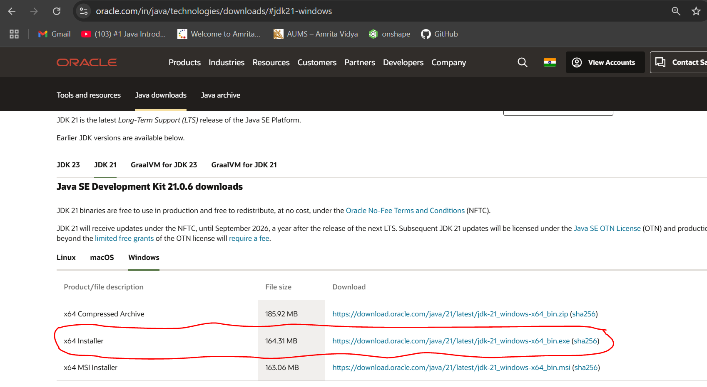

1. **Install JDK:**
   * Once downloaded, run the installer.
   * Follow the instructions and keep clicking "Next" until it's done.
2. **Set Environment Variables (Windows):**
   * For copying of path, go to c drive in file explorer
   * Then click on program files, in program files we can find the Java file click on it the in java file open bin file. Then click on the top of the file location then there we can select the file path location then copy it.
   * Open file explorer, then right click on This PC next select on properties then it will take you to the settings app then click on advanced system settings and then  
     click on **Environment Variables**.
   * Click **New** under **System Variables**:
     + **Set Variable name as:** java_home
     + **Variable value:** The folder address where JDK is installed (like C:\Program Files\Java\jdk-21\bin)
   * Find Path under **System Variables**, click **Edit**, and add the path of the jdk-21(C:\Program Files\Java\jdk-21\bin)  
       
       
       
     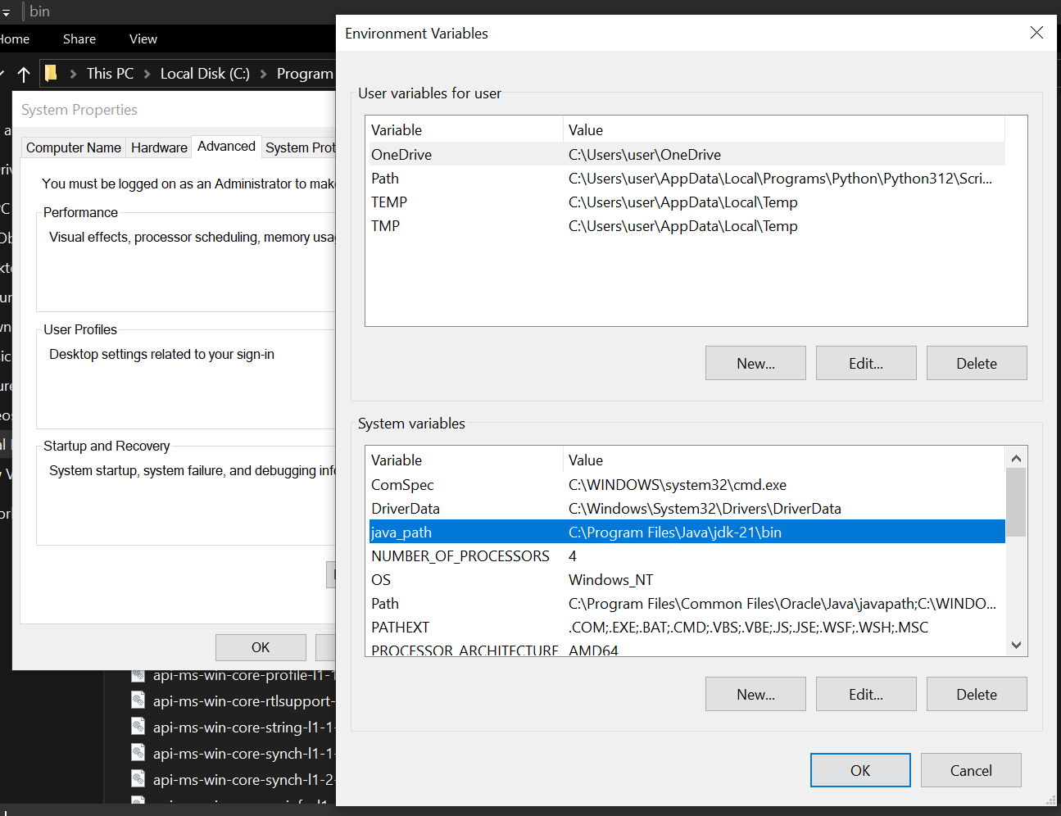

**Checking of JDK Version:**

1. **Open Command Prompt:**
   * Press win+R, type cmd, and press Enter.
2. **Check Version:**
   * Type java --version and press Enter.
   * Type javac --version and press Enter.

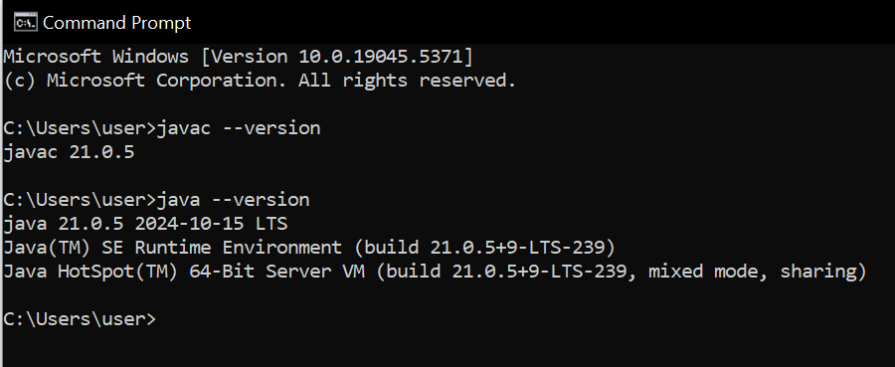

**2) Implement a Java Program to print basic details of a Student**

Write your code in Notepad and execute in cmd prompt

**Important Points:**

* + - * **Understand the syntax of a class.**

class Main {

public static void main(String[] args) {

System.out.println(" ");

}

}

**CODE:**

**The file was saved with Main.java**

class Main

{

public static void main(String[] args)

{

// Printing my basic details

System.out.println("Name: Karthikeya");

System.out.println("Section: CSE-B");

System.out.println("Roll No : 24149");

}

}

**Output:**

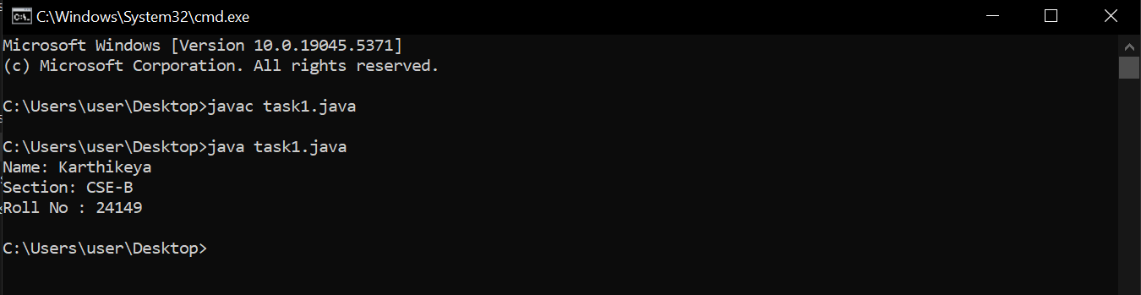

**Errors:**

|  |  |  |
| --- | --- | --- |
| S.NO | Error Name | Error Rectification |
| 1 | Syntax/ Compilation Error | Absence of Semicolon |
| 2 | Closing Brackets | Need to Close the brackets |

**WEEK-2**

1) Write a Java Program to find the factorial of a number

- Write your code in Notepad and execute in cmd prompt

**- Important Points:**

* + - * **Understand the logic of Factorial of number**

int fact=1;

for(int i=num;i>0;i--){

fact=fact*i;

**CODE:**

import java.util.Scanner;

class Main{

public static void main(String[] args){

Scanner input=new Scanner(System.in);

System.out.print("Enter a number: ");

int num=input.nextInt();

int fact=1;

for(int i=num;i>0;i--){

fact=fact*i;

}

System.out.print(num+"!="+fact);

input.close();

}  
}

**Output: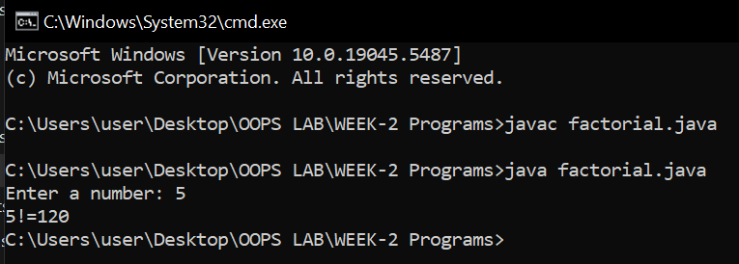 Errors:**

|  |  |  |
| --- | --- | --- |
| S.NO | Error Name | Error Rectification |
| 1 | Syntax/ Compilation Error | Absence of Semicolon |
| 2 | Closing Brackets | Need to Close the brackets |
| 3 | Class Name Error | Give the class name correctly |

2) Write a Java Program to find the Fibonacci series of given Length

- Write your code in Notepad and execute in cmd prompt

**- Important Points:**

* + - * **Understand the logic of Fibonacci Series**

int c=a+b;

a=b;

b=c;

**CODE:**import java.util.Scanner;

class Main

{

public static void main(String[] args){

Scanner input=new Scanner(System.in);

System.out.print("Enter the Length of fibonacci Series:");

int n=input.nextInt();

int a=0;

int b=1;

System.out.println("Series:");

for(int i=0;i<n;i++){

System.out.print(" "+a);

int c=a+b;

a=b;

b=c;

input.close();

}

}

**}**

**OUTPUT:**

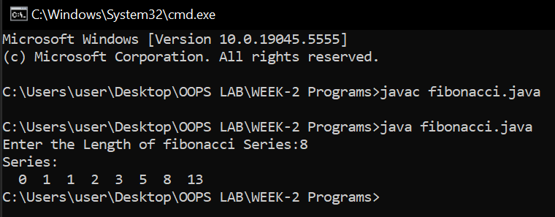

**Errors:**

|  |  |  |
| --- | --- | --- |
| S.NO | Error Name | Error Rectification |
| 1 | Syntax/ Compilation Error | Absence of Semicolon |
| 2 | Closing Brackets | Need to Close the brackets |
| 3 | Class Name Error | Give the class name correctly |
|  |  |  |

3) Write a Java Program for changing of Celsius to Fahrenheit   
  
- Write your code in Notepad and execute in cmd prompt

**- Important Points:**

* + - * **Understand the formula**

f=((9*c/5)+32);

**CODE:**import java.util.Scanner;

class ctof{

public static void main(String[] args){

Scanner input=new Scanner(System.in);

System.out.println("enter the temperature in celsius :");

double c=input.nextInt();

double f=((9*c/5)+32);

System.out.println("the temperature in fahrenheit:"+f);

input.close(); }

}  
  
**OUTPUT:**

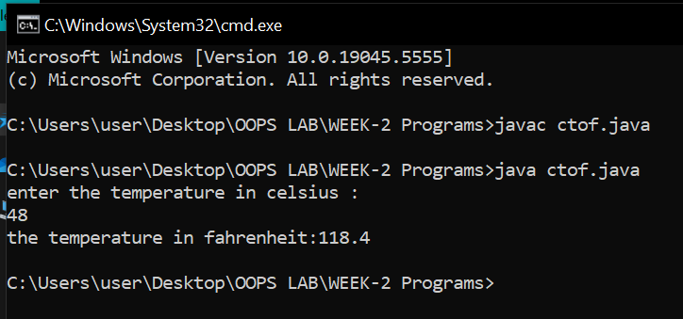

**Errors:**

|  |  |  |
| --- | --- | --- |
| S.NO | Error Name | Error Rectification |
| 1 | Syntax/ Compilation Error | Absence of Semicolon |
| 2 | Closing Brackets | Need to Close the brackets |
| 3 | Class Name Error | Give the class name correctly |

**4) Write a Java Program to calculate the Simple Interest.**

- Write your code in Notepad and execute in cmd prompt

- Important Points:

* + - * Understand the formula

(principal * rate * time) / 100;

**CODE:**

import java.util.Scanner;

public class SimpleInterestCalculator {

public static void main(String[] args) {

Scanner scanner = new Scanner(System.in);

System.out.print("Enter the principal amount: ");

double principal = scanner.nextDouble();

System.out.print("Enter the rate of interest (in %): ");

double rate = scanner.nextDouble();

System.out.print("Enter the time (in years): ");

int time = scanner.nextInt();

double simpleInterest = (principal * rate * time) / 100;

System.out.println("The simple interest is: " + simpleInterest);

scanner.close();

}

}

**OUTPUT:**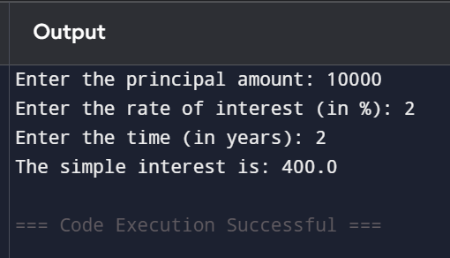

**Errors:**

|  |  |  |
| --- | --- | --- |
| S.NO | Error Name | Error Rectification |
| 1 | Syntax/ Compilation Error | Absence of Semicolon |
| 2 | Closing Brackets | Need to Close the brackets |
| 3 | Class Name Error | Give the class name correctly |

**5) Write a Java Program to calculate the area of triangle using Heron’s Formula**- Write your code in Notepad and execute in cmd prompt

**- Important Points:**

* + - * **Understand the formula**
      * (Math.sqrt(s*(s-a)*(s-b)*(s-c)));

**CODE:**

import java.util.Scanner;

class areat{

public static void main(String[] args){

Scanner input=new Scanner(System.in);

System.out.println("enter the side a :");

int a=input.nextInt();

System.out.println("enter the side b :");

int b=input.nextInt();

System.out.println("enter the side c :");

int c=input.nextInt();

double s=(a+b+c)/2;

double area=(Math.sqrt(s*(s-a)*(s-b)*(s-c)));

System.out.println("Area of triangle :"+area);

input.close(); }

}

**OUTPUT:**

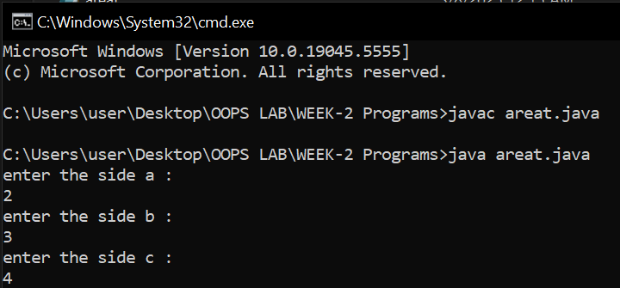

**Errors:**

|  |  |  |
| --- | --- | --- |
| S.NO | Error Name | Error Rectification |
| 1 | Syntax/ Compilation Error | Absence of Semicolon |
| 2 | Closing Brackets | Need to Close the brackets |
| 3 | Class Name Error | Give the class name correctly |

**6) Write a Java Program to find the area of rectangle**

- Write your code in Notepad and execute in cmd prompt

**- Important Points:**

* + - * **Understand the formula**
      * area=a*b;

**CODE:**import java.util.Scanner;

class arear{

public static void main(String[] args){

Scanner input=new Scanner(System.in);

System.out.println("enter the length :");

int a=input.nextInt();

System.out.println("enter the breadth:");

int b=input.nextInt();

double area=a*b;

System.out.println("Area of rectangle :"+area);

input.close(); }

}

**OUTPUT:**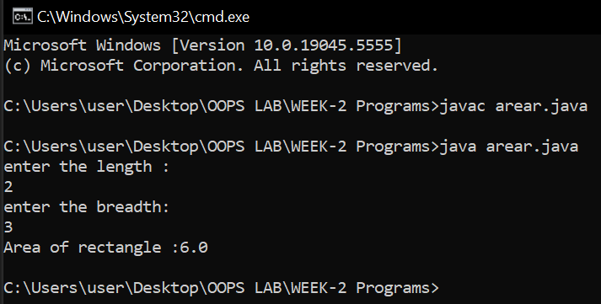

**Errors:**

|  |  |  |
| --- | --- | --- |
| S.NO | Error Name | Error Rectification |
| 1 | Syntax/ Compilation Error | Absence of Semicolon |
| 2 | Closing Brackets | Need to Close the brackets |
| 3 | Class Name Error | Give the class name correctly |
| 4 | Formula Error | Write the formula correctly |

**WEEK-3**

1) **Write a java program with the following instructions:**

**a. Create class with name car.**

**b. Create 4 attributes named car color, car brand, fuel type, mileage.**

**C. Create 3 methods named start (), stop(), service ().**

**d. Create 3 objects C1, C2, C3.**

**e. Create a constructor with parameters with car color, car brand, fuel type, mileage.**

- Write your code in Notepad and execute in cmd prompt

**- Important Points:**

* + - * Understand the calling of a Constructor

**CODE:**class Car{

String color;

String brand;

String fuel_type;

double milage;

public Car(String color,String brand,String fuel_type,double milage){

this.brand=brand;

this.color=color;

this.fuel_type=fuel_type;

this.milage=milage;

System.out.println("car brand:"+brand+" car color:"+color+" car fuel-type:"+fuel_type+" car milage:"+milage+"km");

}

public void start(){

System.out.println(brand+" it is well known car "+color+" is iconic color "+fuel_type+" is source and of milage "+milage+"km");

}

public void stop(){

System.out.println(brand+" it is well known car "+color+" is good color "+fuel_type+" is source and of milage "+milage+"km");

}

public void service(){

System.out.println(brand+" it is well known car for its speed "+color+" is beautiful color"+fuel_type+" is source and of milage "+milage+"km");

}

public static void main(String[] args){

Car c1=new Car("BMW","Black","petrol",150);

c1.start();

Car c2=new Car("petrol","oddi","Blue",130);

c2.stop();

Car c3=new Car("red","Tesla","e-power",200);

c3.service();

}

}  
  
  
  
**OUTPUT:**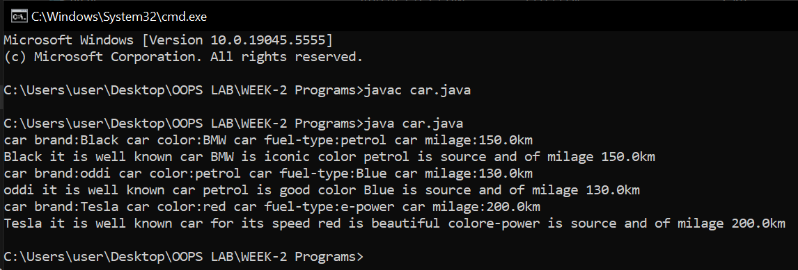

**Errors:**

|  |  |  |
| --- | --- | --- |
| S.NO | Error Name | Error Rectification |
| 1 | Syntax/ Compilation Error | Absence of Semicolon |
| 2 | Closing Brackets | Need to Close the brackets |
| 3 | Class Name Error | Give the class name correctly |
| 4 | Constructor Calling | Call the constructor correctly |

2) **Create a class named bank account with methods deposit and withdraw. Where the deposit method should accepts a parameter and when this method is called the deposited amount should be added to current balance. In addition to that when a withdraw method is called it has to verify whether the withdraw amount is less than the current balance. If not display message saying that there are insufficient funds. Use the constructor to display the details of the customer (Name, Account number, IFSC code, Branch). Also create two customer objects C1, C2.**

- Write your code in Notepad and execute in cmd prompt

**- Important Points:**

* + - * Understand the calling of a Constructor
      * Giving class name correctly

CODE:  
import java.util.Scanner;

class Bank_account{

long current_balance;

String name;

String account_number;

String IFSE;

String branch;

Scanner input=new Scanner(System.in);

public Bank_account(long current_balance,String name,String account_number,String IFSE,String branch){

this.current_balance=current_balance;

this.name=name;

this.account_number=account_number;

this.IFSE=IFSE;

this.branch=branch;

System.out.println("User name:"+name+" account_number:"+account_number+" IFSE details:"+IFSE+" branch number:"+branch);

}

public void deposit(){

System.out.println("enter the depositing amount: ");

long deposit_amount=input.nextLong();

long sum=current_balance+deposit_amount;

System.out.println("the current blance after depoisting is "+ sum);

}

public void withdraw(){

System.out.println("enter the withdrawing amount: ");

long withdraw_amount=input.nextLong();

long dum=current_balance-withdraw_amount;

if(dum>0){

System.out.println("the current blance after withdrawal is "+ dum);}

else{

System.out.println("the current blance is insufficent ");

}

}

public static void main(String[] args){

Scanner input=new Scanner(System.in);

System.out.println("enter the Balance amount: ");

long amount=input.nextLong();

Bank_account a1=new Bank_account(amount,"moksha","123456789","abcd","533432");

a1.deposit();

System.out.println("enter the Balance amount: ");

long amount1=input.nextLong();

Bank_account a2=new Bank_account(amount1,"honey","961","abcd","533432");

a2.withdraw();

}

}

**OUTPUT:**

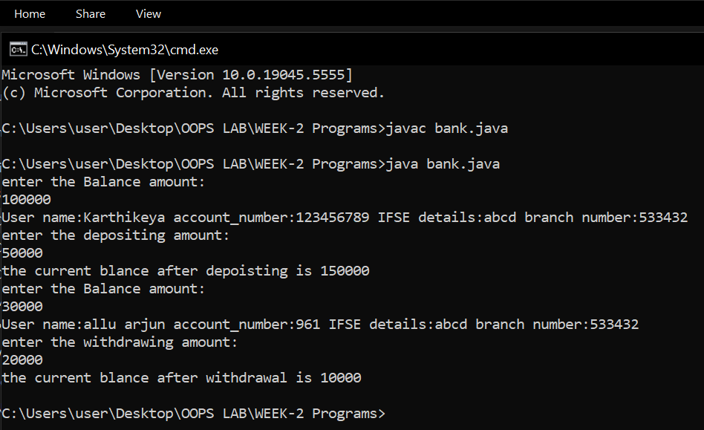 **Errors:**

|  |  |  |
| --- | --- | --- |
| S.NO | Error Name | Error Rectification |
| 1 | Syntax/ Compilation Error | Absence of Semicolon |
| 2 | Closing Brackets | Need to Close the brackets |
| 3 | Class Name Error | Give the class name correctly |
| 4 | Constructor Calling | Call the constructor correctly |
|  |  |  |